QUESTLABS COMPANION

Project Proposal

INFS 3375 - Section 1

*From present awareness to future possibilities—together*

STUDENT 1:

Zhi Kang

STUDENT 2:

Dong Zhang

Fall 2025

Instructor: Padmapriya Arasanipalai Kandhadai

**Contents**

**QUESTLABS COMPANION 1**

**Project Proposal 1**

**TITLE 3**

App Name 3

App Description 3

Team Members 3

**INTRODUCTION 3**

Describe 3

Novelty 3

Transformative Experience 4

Motto 4

**BACKGROUND RESEARCH 4**

Market Competitors 4

**Market Inspiration 6**

**(1) Holistic Integration 6**

**(2) Small Group Accountability 6**

**(3) Quick + Structured 6**

**PACT FRAMEWORK 7**

People 7

Activities 7

Context 7

Technologies 7

**VALUE PROPOSITION 8**

**PROJECT CONTRACT 8**

**PRELIMINARY FEATURES LIST 9**

1. Three-Layer Goal Framework 9

2. Daily Check-In (<2 min) 9

3. Weekly Planning (5-10 min) 9

5. Progress Dashboard 9

6. Cohort Space 9

**AI USE SECTION 10**

**AI Tools Used 10**

**- PACT framework application 10**

**WORK LOGS 10**

StudentName: Zhi Kang 10

StudentName: Dong Zhang 12

# TITLE

## App Name

questlabs companion

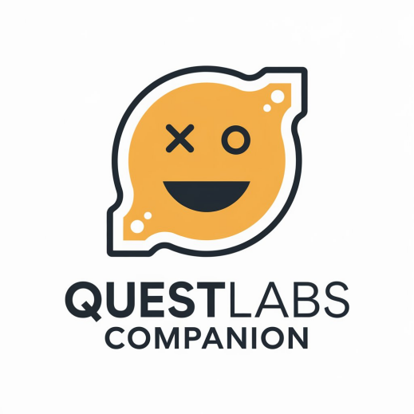

## App Description

A holistic growth companion for college students, integrating emotional wellness, relationship tracking, and goal progress within structured peer communities.

## Team Members

Team leader: Zhi Kang

Student ID: 300403869

E-mail: kangz4@student.douglascollege.ca

Team member: Dong Zhang

Student ID: 300403848

1. mail: windyheratz5201314@gmail.com

Course section: CSIS 3375 001

# INTRODUCTION

## Describe

QuestLabs Companion integrates emotional wellness, relational quality, and academic progress tracking for college students in cohort-based programs. The app provides daily reflection prompts (under 2 minutes), three-layer goal frameworks (vision → quarterly → weekly), and peer accountability within small groups of 5-10 students.

## Novelty

Unlike single-purpose apps (Daylio for mood, Todoist for tasks), QuestLabs Companion treats life dimensions as interconnected. It serves known small groups rather than anonymous communities, emphasizing collaborative growth over competition through an intentionally anti-gamified design.

## Transformative Experience

Students shift from reactive to intentional living through structured reflection, developing metacognition about their own patterns. The cohort structure provides accountability without judgment, while the three-layer framework connects daily actions to future aspirations.

## Motto

"From present awareness to future possibilities—together."

# BACKGROUND RESEARCH

## Market Competitors

1. **Daylio:** Mood tracker with quick icon-based logging and statistical analysis. Strong individual tracking but no community features or goal integration.

2. **Habitica:** Gamified habit tracker with party/guild features. Effective motivation but competitive design contradicts collaborative growth philosophy.

3. **Reflectly:** AI-powered journal with adaptive prompts. Entirely individual focus, requires 5-10 minutes daily, premium features cost $60/year.

4. **Strides:** Flexible goal/habit tracker with strong data visualization. No emotional context or social features.

5. **Notion:** Customizable workspace for notes and tasks. Powerful but overwhelming for users seeking structured guidance.

**Gap:**

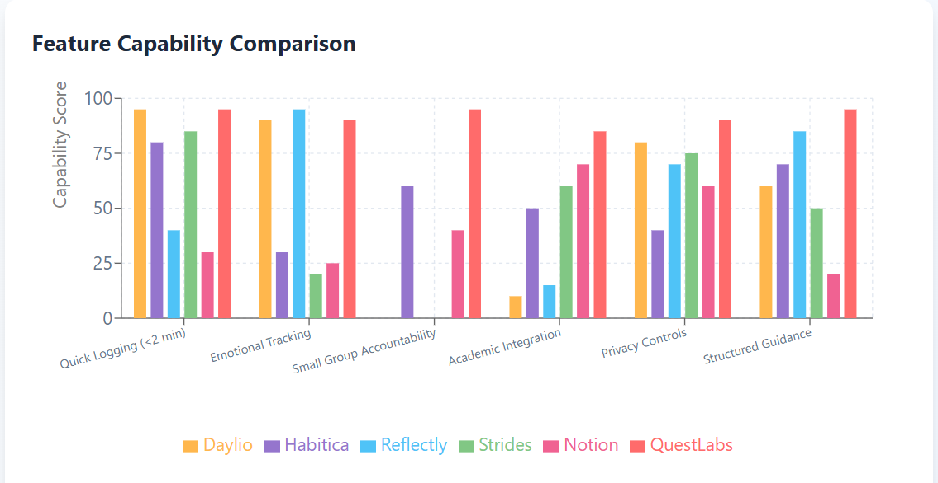

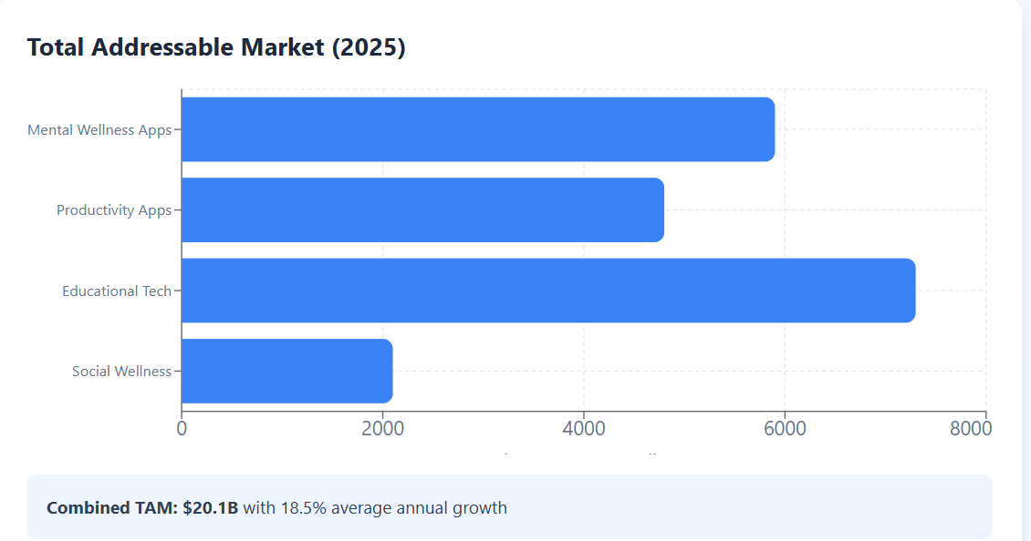

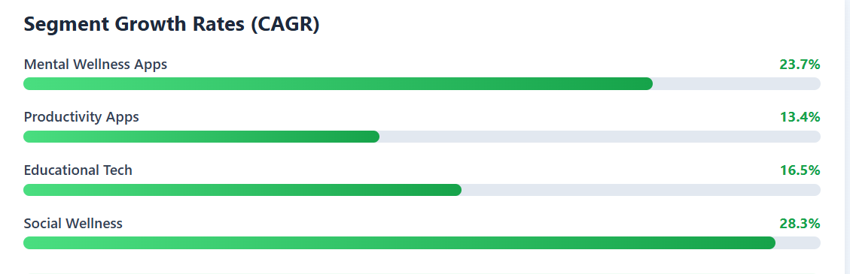

**Highest Growth: Social Wellness (28.3%) and Mental Wellness (23.7%) - QuestLabs' core focus areas**

No existing app integrates emotional wellness, relational quality, and academic progress within small-group accountability frameworks.

*Source:* <https://www.grandviewresearch.com/industry-analysis/mental-health-apps-market-report>

<https://www.fortunebusinessinsights.com/mental-health-apps-market-109012>

https://www.businessresearchinsights.com/market-reports/productivity-apps-market-117791

<https://media.market.us/mental-health-apps-market-news-2024/>

https://upbase.io/blog/18-best-productivity-apps-for-students/

**Market Inspiration**

1. **Strava:** Privacy-preserving social visibility—users see peers' activity without detailed data. Applied to QuestLabs through aggregated cohort progress displays.

2. **Forest:** Visualizes abstract progress (focus time) as tangible growth (trees). Applied through journey metaphors for personal development.

3. **Discord:** Channel-based community organization. Applied through cohort-specific structured spaces.

So for the QuestLabs, we can focus on the specific features and do our designs:

1. **Holistic Integration**

Only app combining emotional wellness, relational quality, and academic progress in one platform

1. **Small Group Accountability**

Privacy-preserving cohort system inspired by Strava's social model - see progress without exposed data

1. **Quick + Structured**

Under 2 minutes daily with guided prompts - combines Daylio's speed with Reflectly's guidance

**Insight:**

Simplicity (<2 min daily), structured guidance, and privacy-aware community features drive sustained engagement.

# PACT FRAMEWORK

## People

**Primary:** College students (18-30) in structured development programs. Digitally fluent but time-constrained, seeking meaningful engagement over passive consumption. Value peer connection within small trusted groups.

**Secondary:** Program facilitators needing aggregated cohort insights without individual privacy invasion.

## Activities

**Goal Management (Time-spanning):**

1. Future visioning (one-time, 15-20 min): Articulate 3-year aspirations

2. Quarterly goal setting (every 3 months, 10-15 min): Align with vision

3. Weekly planning (weekly, 5-10 min): Set specific actions

4. Daily progress tracking (daily, <1 min): Note which goals worked on

**Reflection & Awareness:**

1. Daily emotional check-in (daily, 1-2 min): Rate three dimensions

2. Reflection entries (2-3x/week, 2-5 min): Process experiences

3. Monthly progress review (monthly, 5-10 min): Visualize trends Community

4. Cohort engagement (2-3x/week, 3-5 min): View peer progress, encourage

## Context

- Physical: Dorm rooms, libraries, commute; smartphone primary device

- Temporal: Morning (7-9am) or evening (9-11pm); must fit <5 min windows

- Social: Small cohorts (5-10) with face-to-face meetings; privacy essential

- Emotional: Users often stressed, seeking grounding not judgment

- Technical: Reliable connectivity assumed; lightweight design required

## Technologies

**Required:**

- Cross-platform mobile framework (React Native/Flutter)

- Cloud database & authentication (Firebase/Supabase)

- Data visualization (Recharts/Victory)

- Push notifications (FCM/OneSignal)

- Offline storage (AsyncStorage)

**Key Insights:**

Time-constrained users in interruptible contexts require activities under 2 minutes with mobile-optimized, privacy-preserving community features and structured guidance over flexibility.

# VALUE PROPOSITION

For college students in structured personal development programs who need to sustain reflection and goal progress beyond program duration,

QuestLabs Companion is a mobile tracking tool that integrates emotional wellness, relational quality, and academic goals while connecting daily actions to long-term aspirations within small peer cohorts.

Unlike standalone mood trackers, gamified habit apps, or overwhelming flexible tools, our app provides structured three-dimensional tracking designed for small known groups, emphasizing collaborative growth over individual competition.

# PROJECT CONTRACT

We agree to the following collaboration terms for QuestLabs Companion:

Meetings: Three times per week (By the Onsite and online ways)

Communication: using WhatsApp program group, offline, respond within 24 hours

Work Distribution: Equal workload, tasks assigned in meetings, every one will contribute ourselves best efforts

Deadlines: Complete work 48 hours before submission for team review

Conflict Resolution: Direct discussion first, then team meeting, then instructor

AI Usage: Document all use, save prompts, no direct copy-paste

**Signed:**

__Zhi ________ _Kang____ Team Lead: Zhi Kang

__Dong_______ _Zhang___ Member 2: Dong Zhang

# PRELIMINARY FEATURES LIST

**Core Features:**

1. Three-Layer Goal Framework

Long-term vision → Quarterly goals → Weekly actions

2. Daily Check-In (<2 min)

Rate emotional/relational/academic (1-5), mark goal progress

3. Weekly Planning (5-10 min)

Review past week, set actions for coming week

4. Structured Reflection Journal

Fill-in-the-blank prompts, tag themes, timeline view

5. Progress Dashboard

Trend graphs, goal completion rates, pattern insights

6. Cohort Space

Aggregated peer progress, encouragement reactions, group milestones

**Intentionally Excluded:**

Gamification, AI insights, open social features, real-time chat

# AI USE SECTION

**AI Tools Used**

AI Tool Name: Claude (Anthropic)

Version: Sonnet 4.5,

Account Type: Pro

Specific Use: Project analysis, Survey Questionnaire design, competitive research

**Value Addition Over AI**

Our team added:

- Critical analysis of founder's business model vs. project requirements

- User research insights from peer discussions

- Feature prioritization based on realistic project constraints

- PACT framework application

- Design philosophy (anti-gamification, small-group focus)

- Honest market positioning acknowledging existing competitors

# WORK LOGS

## StudentName: Zhi Kang

Represented finished tasks

Represented planning tasks

|  |  |  |
| --- | --- | --- |
| **Date** | **Number of Hours** | **Description of work done** |
| Sep 28, 2025 | 1.0 | Choosen our program topic, and met with professor for the first meering |
| Oct 1, 2025 | 3.5 | Project kickoff meeting with team Makēda; Started researching futures literacy concepts and some key steps for the program |
| Oct 4, 2025 | 3 | Met with team to align on research direction; Reviewed 2020 wireframe example to understand design evolution, and wrote the program proposal |
| Oct 7, 2025 | 3.5 | Shared interview findings in team check-in; Conducted 3 student interviews about their reflection habits and support needs |
| Oct 9, 2025 | 3.5 | Presented research synthesis to team; Researched engagement patterns in micro-journaling apps and compiled best practices |
| Oct 11, 2025 | 3.5 | Started learning Figma with team; Analyzed interview data and created affinity diagram showing key themes |
| Oct 14, 2025 | 3.5 | Learned Figma basics including frames and mobile layouts; Created user journey map identifying 6 touchpoints |
| Oct 16, 2025 | 3 | Explored advanced Figma prototyping features; Completed tutorial on frames, constraints, and 375px mobile design |
| Oct 18, 2025 | 3.5 | Discussed wireframing approach with team; Practiced Auto Layout and built responsive card components |
| Oct 21, 2025 | 4.5 | Started wireframing phase - divided sections with team; Learned prototyping tools and created 6-screen demo |
| Oct 23, 2025 | 4 | Reviewed wireframes and got feedback from team; Drew paper sketches for Section 1 with 8 different screens |
| Oct 25, 2025 | 4 | Planned Section 3 cohort features; Created digital wireframes for daily prompt system with 6 screens |
| Oct 28, 2025 | 4 | Reviewed design system standards with team; Wireframed support request feature with micro-reflection forms |
| Oct 30, 2025 | 4.5 | Started high-fidelity design phase; Designed collaborative Battleship concept for cohort section |
| Nov 1, 2025 | 4 | Progress check with team on designs; Created BINGO wireframes with challenge grid and celebration screens |
| Nov 4, 2025 | 4.5 | Design sprint review meeting; Finished all Section 3 wireframes including cohort dashboard and peer features |
| Nov 6, 2025 | 4.5 | Discussed navigation integration; Applied design system to Section 1 creating polished prompt screens |
| Nov 8, 2025 | 3.5 | Confirmed all screens ready for prototyping; Designed MadLibs journaling interface with playful illustrations |
| Nov 11, 2025 | 5 | Kicked off prototyping work; Completed high-fidelity Section 3 designs with badges and celebration animations |
| Nov 13, 2025 | 4.5 | Prepared user testing scenarios; Designed onboarding flow with 4 welcome screens and bottom navigation |
| Nov 15, 2025 | 3.5 | Discussed testing results with team; Polished Section 1 and 3 screens by refining spacing and colors |
| Nov 18, 2025 | 4 | Planned iteration based on feedback; Built clickable prototype connecting 18 screens with transitions |
| Nov 20, 2025 | 4 | Reviewed accessibility requirements; Integrated navigation system linking all sections with working tab bar |
| Nov 22, 2025 | 3.5 | Final validation before deliverables; Ran usability tests with 3 participants and documented feedback |
| Nov 25, 2025 | 4.5 | Planned final deliverables with team; Refined prototype based on user feedback improving 8 screens |
| Nov 27, 2025 | 4.5 | Set up GitHub repository structure; Added micro-interactions and finalized all prototype connections |
| Nov 29, 2025 | 4.5 | Divided final submission tasks; Organized Figma file with clean layers and 5-page structure |
| Dec 1, 2025 | 7 | Created GitHub repo and uploaded assets; Wrote comprehensive README and submitted final deliverables |

## StudentName: Dong Zhang

|  |  |  |
| --- | --- | --- |
| Date | Number of Hours | Description of work done |
| Sep 28, 2025 | 1.0 | Choosen our program topic, and met with professor for the first meering |
| Oct 1, 2025 | 3.5 | Project kickoff meeting with team Makēda; Started researching futures literacy concepts and some key steps for the program |
| Oct 4, 2025 | 3 | Met with team to align on research direction; Reviewed 2020 wireframe example to understand design evolution, and wrote the program proposal |
| Oct 7, 2025 | 3.5 | Shared survey results in check-in meeting; Created Google Forms survey and collected 15 student responses |
| Oct 9, 2025 | 3.5 | Presented key research findings; Studied collaborative game mechanics like Battleship and BINGO |
| Oct 11, 2025 | 3.5 | Divided Figma learning modules; Analyzed survey data showing 70% prefer visual tracking |
| Oct 14, 2025 | 3.5 | Learned Figma interface basics; Built feature prioritization matrix ranking 12 potential features |
| Oct 16, 2025 | 3 | Explored advanced Figma features; Completed tutorial on layers, properties, and design modes |
| Oct 18, 2025 | 3.5 | Discussed wireframing strategy; Created button component library with 4 different states |
| Oct 21, 2025 | 4.5 | Established design standards with team; Set up color styles with 8 colors and typography scales |
| Oct 23, 2025 | 4 | Got feedback on initial wireframes; Sketched Section 2 Dashboard showing affect-agency grid ideas |
| Oct 25, 2025 | 4 | Discussed cohort features planning; Created dashboard wireframes with wellness snapshot and stats |
| Oct 28, 2025 | 4.5 | Presented design system structure; Wireframed Polak's Affect-Agency grid with 4 interactive quadrants |
| Oct 30, 2025 | 4.5 | Reviewed design system application; Created Wheel of Life wireframe with 8-spoke design |
| Nov 1, 2025 | 4.5 | Progress check on high-fidelity work; Designed SEL timeline showing emotional trends over time |
| Nov 4, 2025 | 4.5 | Design sprint with final tasks; Built comprehensive design system with colors, fonts, and spacing |
| Nov 6, 2025 | 4 | Discussed app flow and transitions; Created component library including buttons, inputs, and cards |
| Nov 8, 2025 | 3.5 | Confirmed screens ready for prototype; Applied design system to dashboard with polished grid |
| Nov 11, 2025 | 5 | Started prototyping phase; Designed Wheel of Life and SEL timeline with interactive visualizations |
| Nov 13, 2025 | 4 | Prepared testing materials; Built project progress screens linking tasks with emotional well-being |
| Nov 15, 2025 | 4 | Reviewed testing insights; Designed Google Forms integration and various input components |
| Nov 18, 2025 | 4.5 | Prioritized feedback for iteration; Created clickable prototype for Section 2 dashboard features |
| Nov 20, 2025 | 4 | Discussed accessibility compliance; Added tappable grids and draggable wheel interactions |
| Nov 22, 2025 | 4 | Final validation before submission; Participated in coaching activity beta test and documented UX insights |
| Nov 25, 2025 | 4.5 | Outlined design report structure; Simplified dashboard visualizations based on user confusion |
| Nov 27, 2025 | 5 | Reviewed GitHub requirements; Conducted WCAG accessibility audit and compiled 10-page style guide |
| Nov 29, 2025 | 4.5 | Divided documentation tasks; Wrote design report covering research insights and design process |
| Dec 1, 2025 | 7.5 | Finished design report and technical docs; Created supporting files and submitted all deliverables |